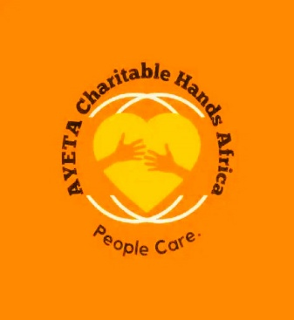
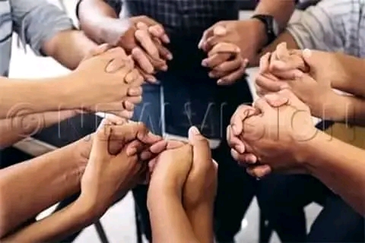
_{Ayeta charitable hands Africa.}
ANNUAL REPORT

20
21

Email: [ayetacharitablehandsafrica@gmail.com]

Website: [ Ayetacharitablehandsafrica.org]

Tell: +256756341107
Adrress: Ayeta charitable hands Africa P.O.BOX 1534, Mbale, Uganda.

Table of contents.

ANNUAL OVERVIEW
2021 at- a glance
Introduction message from the C.E.O. --------------------------------------------------------- 1
Financial high lights.---------------------------------------------------------------------------------- 2
Activity highlights.------------------------------------------------------------------------------------- 3
Project highlights.--------------------------------------------------------------------------------------4

ACTIVITY SUMMARY/PROGRAM
Locations-------------------------------------------------------------------------------------------------5
Expenses Needed--------------------------------------------------------------------------------------7
Assets------------------------------------------------------------------------------------------------------8

PROJECTS.
Locations--------------------------------------------------------------------------------------------------9
Expenses--------------------------------------------------------------------------------------------------10
Statistics--------------------------------------------------------------------------------------------------11
Outcomes------------------------------------------------------------------------------------------------12

LEADERSHIP
Executive-------------------------------------------------------------------------------------------------13
Board of directors.-------------------------------------------------------------------------------------14

IMPACT

2021 ANNUAL OVERVIEW

2

TABLE OF CONTENTS

ANNUAL OVERVIEW

(
You will need to change the page #
’s
)

_____________

3

2021
At
-
A
-
Glance

________________________________
_________________________

3

Financial Highlights

________________________________
_______________________

3

Activity

Highlights

________________________________
_________________________

3

Project Highlights

________________________________
_________________________

3

ACTIVITY

S
UMMARY

________________________________
____________

4

Location(s)

________________________________
______________________________

4

Expenses Needed

________________________________
________________________

4

Statistics

________________________________
________________________________

4

Outcomes

________________________________
_______________________________

4

FINANCIAL SUMMARY
________________________________
___________

5

Revenue

________________________________
________________________________

5

Expenses

________________________________
_______________________________

5

Assets
________________________________
________________________________
__

5

PROJECT
(
S
)

________________________________
___________________

6

Locations(s)
Accounts

________________________________
______________________

6

Expenses

________________________________
_______________________________

6

Statistics

________________________________
________________________________

6

Outcomes

________________________________
_______________________________

6

LEADERSHIP

________________________________
__________________

7

Executive Team

________________________________
__________________________

7

Board of Directors

________________________________
________________________

7

I
MPACT

________________________________
_______________________

8

2021 At-A-Glance.

Introduction by the C.E.O(ACHA).

The Ayeta charitable hands Africa organization is a 501©(3) based on Christian religious principles, it’s a private nonprofit, non-tribal, non-political, non-sectarian and non-governmental organization. A body cooperate worth a common seal, perpetual succession worth capacity to sue or to be sued. It’s working impact is to help support the needy, vulnerable children & orphans through child Developemental milestones in different aspects of a life need, thus education, water & sanitation, sports, health etc.
The word “Ayeta” means God help in in Gishu language.
The Ayeta charitable hands Africa organization was found since 2019 but on low grounds until was organised and fully registered as C.B.O at a REG NO NAM/856.
The Ayeta charitable hands Africa organization was founded by Mayanja Jackson.
Mayanja Jackson as the c.e.o and the team invites every one out there to join together our hands and support those that are in need

Financial Highlights

Activity Highlights
• To provide orphan / semi orphan / street children, a childhood that they never experienced and help them to become useful members of the society.
• To encourage orphan / semi orphan / street children to kindle their potential by providing creative opportunities
• To make available a secure place where orphan / semi orphan / street children can play and enjoy their childhood.
• To provide basic education to orphan / semi orphan / street children.
• To provide such welfare services like free lodging, boarding, health and recreation • To provide basic literacy and facilities for those who wish to study further
• To select and prepare for a vocation in order to live on their own legs
• To accomplishing physical, intellectual and aesthetic development of the child Project Activities:
Our daily Project activities.
What we do in our organizational daily programs as a routine, is that always we follow our time table organization schedule/ programs of the day as planned.
Every morning, we wake up and together and offer a prayer, get to for hygiene, brushing our teeth/ take a shower.
Depending on children’s age and potentiability is what we follow in order to give responsibility of work/ activity. As always spending time with them in doing singing and dancing is the most fruitful to them. With no doubt, fun is the most important in our life. But doing valuable activities with them is worth it.
Talking with them and Knowing their daily routines, what’s on there minds, there future wishes and prospects is more interesting in creating a loving atmosphere in them.
Painting : We do the paintings and drawings in the books that creates love and friendship with them.
Speaking English : daily use sentences and learning of eg….
Parts of body names
Good habits
Traffic rules
Eating habits
Speaking skills : how to speak with elders or younger ones.
Gardening
Teach mathematics : count no of objects, sorting toys according to their size shape color
Exercise
Tree and environment names
Visual aids most especially watching Christian bible movie stories to help in learning most things about God and Jesus Christ. Kids becomes very excited when they see some videos or something.
Identification of orphan / semi orphan / street children
Pre-view of the incoming orphan / semi orphan / street children problem/difficulties
Emotional acceptance of the child Teaching facilities for basic education
Teaching facilities for vocational courses and craft lodging and boarding facilities for all inmates.
Recreational facilities.
Primary health.

“In every desert of calamity, God provides an oasis of confort” . Through you our beloved friends all around the world, you’ve been our piramid to stand and a comfort that God provides to help and support our organizational(A.C.H.A’s)cause, it’s objective, aims and obligations, vision and mission. We love you and pray for you always that that our Lord grant you success and all that he sees fit for you. Please thank you so much and keep on asking for support please and help us reach our goals..

Project Highlights
Education: In our project main stream, education is one major key component were looking at concurrently by providing educational facillities to the orphans, the needy, street children etc . As of now we have 174 orphans that were trying our level best to help support them. We have an orphanage glorious school we striving to construct that we know will help reduce on the amount of money paid for there tuition on different schools since there so expensive.
Shelter. We rent an orphanage home where we help support most especially those left alone and can’t merely support themselves. We keep them in our organisational rental home.
Water and sanitation: As the organization, our role is to speak out on behalf of whatever tames hearts and minds most especially on the things that we see can greatly change a life from worse to good, impactfully bringing in a new ideological way of life and living . Currently we’ve been able to connect with one other Organisation that have been helping in digging water Wells for the community. And we so glad for that tremendous work done
Sports: During the pandemic error of Covid 19, it’s from where as the organization came up with this idea after seeing so many young girls who were not in school going for early marriages, young boys getting into thug groups, involving in stealing, pick pocketing, playing cards, fighting, smuggling and all sorts of immoral characters. So we opened up a soccer academy where we organised and trained them both genders, the young and the youths. This helped a lot cause in this we taught them love, made them busy on nurturing there talent than instead of chasing for bad things And so far we two girls and five boys on a soccer bursary at St Peter’s high school in Hoima

ACTIVITY SUMMARY/PROGRAM.
 | To be done by | Q1 |  |  | Q2 |  |  |  | Q3 |  |  | Q4
 |  | MONTH |  |  | MONTH |  |  |  | MONTH |  |  | MONTH
 |  | 1 | 2 | 3 | 4 | 5 | 6 |  | 7 | 8 | 9 | 10 | 11 | 12
- To assist the orphans to acquire education in NAMISINDWA and bumaafu villages.
- Identify 174 orphans and other vulnerable children (OVCs) | - Social worker  - Local workers
- Take pictures of vulnerable children (OVCs) | - Social worker
- Have their profiles updated-to be done by the social worker | - Social worker
- Organize 3 meetings for guardians and local leaders | - Social worker
- Identify land and build a school of 7 classrooms | - Local leaders  - Project director  - Committee
- Pay school fees; buy uniforms, books, pens, and scholastic materials.  - Organize a Christmas and end of year parties for the children. | - Social worker  - Local leaders  - Project director
- To support 174 needy children with educational facilities and to provide 1 borehole in the community
{Namisindwa}
- Identify sick children | - Health trainer  - Committee
- Provide health seminars and counseling | - Health trainer  - committee
- Provide food to the children | - Health trainer  - Volunteers
- Build a health unit at school | - Health trainer  - Local leaders  - Project director
- Provide 174 mosquito nets to the needy children | - Health trainer  - Local leader
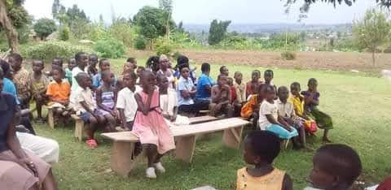
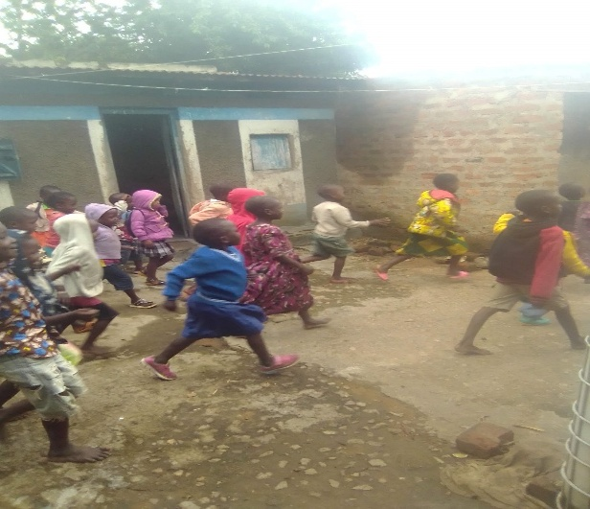
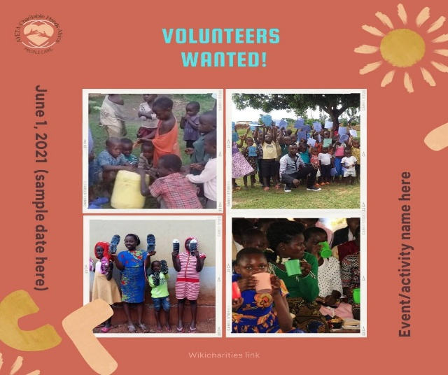
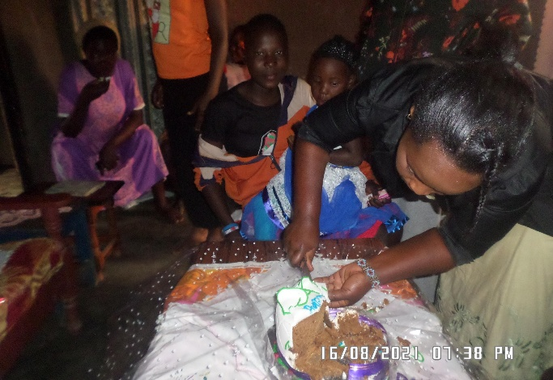
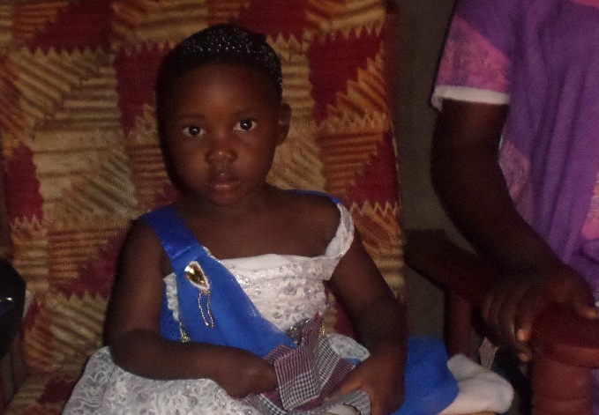
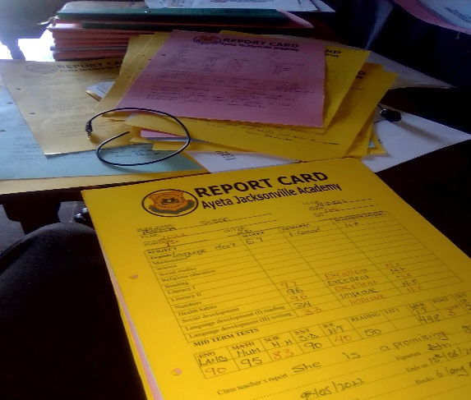
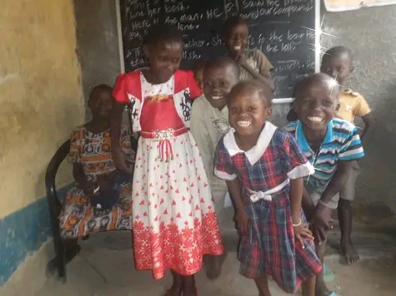
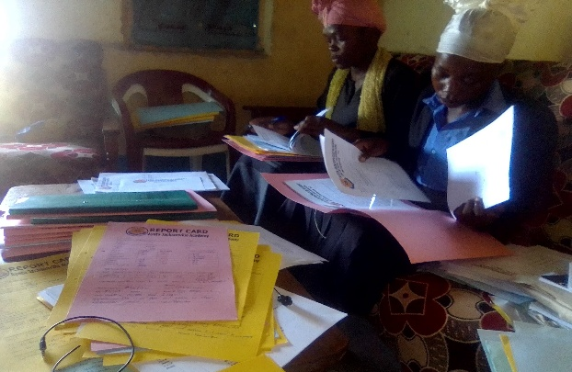
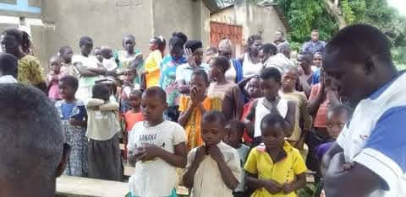
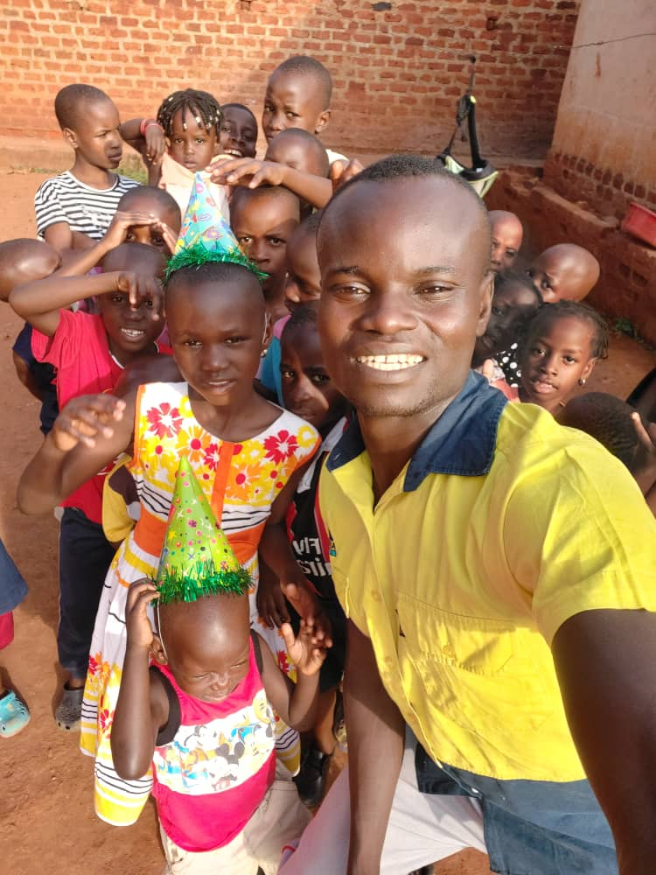
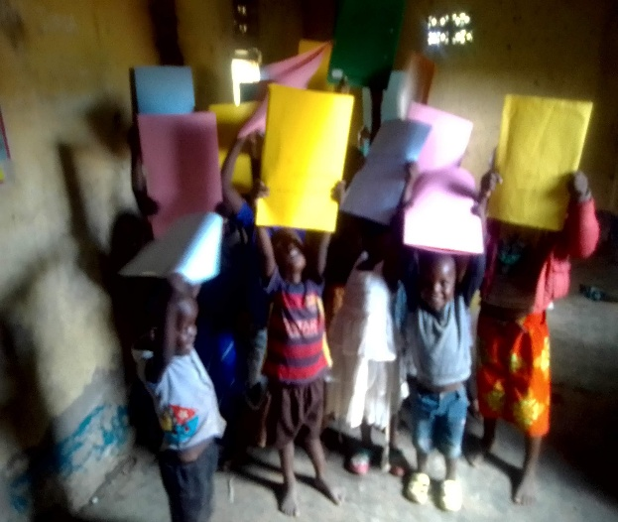
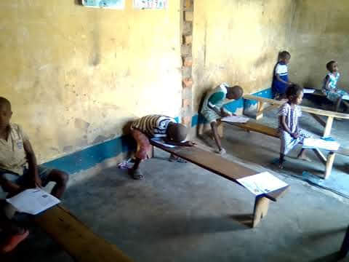
Taking our studies under a shade of a mango tree before our rental

FINANCIAL SUMMARY

Summary of Revenue
- Funders
- Fundraisers
- Revenue Models

Summary of Expenses
- Salaries
- Program Expenses
- Fundraising Expenses
- Marketing Expenses
REVENUE
Funders

Fundraisers

Revenue Models

Revenue

Amount
EXPENSES
 |  |  | Salaries | 19,500
 |  |  | Program Expenses.  Fundraising Expenses.  Marketing Expenses | 46,808$  100$  90$
Expenses

Amount
ASSETS
Land  School  Farming |  |  | 20,000$  10,000  1500

☐ Summary of revenue.
In Uganda, Non-profit organizations are exempted from paying the revenue” the only revenue asked for is paid only during when opening up and chasing for the organisation starting at local government level up to the district level at the (CAO's) office. Once charged that then no more charges taken you except the renewal charges as dictated. Every single for the renewal of the certificate, you pay certain amount of money asked .
☐ Summary of Expenses
(In our organisational expenses overview/structure, The expenditure listed in the box below was spent majorly on all most sorts of activities done in 2022. It was sent onto run different activities in our four different areas, thus.
- Sports activities
- Orphanage and all its requirements
- Healthy water engagements.
- Farming etc.

PROJECT(S)

Project 1
Education. In our organization, we have an orphanage home and school where we rent to help support both the orphans, vulnerable children and the needy children. We provide education, food and all that offered to child developmental milestones. We have 174 orphans and vulnerable children that were taking care of.
Project 2
Sports. During Covid 19 out break some how came to an ease, many people got affected in different patterns of life need and so forth. But in Namisindwa, it was announced even on TV how many youths had gone so wild, engaging in crime, early marriages, smuggling at lwakhakha border and a few lost there lives and ended in jail because of found with illegal goods smuggled in Uganda from Kenya. So as the organization we thought out for an idea onto how we could help our youths from all such kinds of problems rising each day. We visited the local officials both lower level and upper district, we organised with them and called up many youths to come here about our messages. We talked and listened to there ideas as to why more so we’re doing such crimes. Most of them complained, there not in school and have nothing to do . So we organised a soccer academy for both genders. We hired a coach to train them skills that would help them further in there future.It all went on successful and many joined, we bought all that we could afford to make it a success. So far now we have four of them schooling on a soccer bursary.
Project 3
Water and sanitation. Our water project came about when after many people had witnessed what we were doing around, being the speaker to the voiceless as an organization. One day we received a visitor, an old man called Makambi Bumali, They had a problem of drinking poor dirty water and there well had drained due to too much sun shine. The whole community were suffering and all they we’re doing was to dig pot whole around to find water, every hole they would dig and find little water, they would drink and finish it in just one day. So I went there and took videos and pictures with them. I loaded them on my website asking for support if they would be any one to come in support construct them a borehole, it took some time till of recently this last month of June/2022 came a friend that connected us to this other Organisation that has sponsors’ of constructing clean water projects. They help and dug for them and now Mr Bumali Makambi has clean water well and the community.
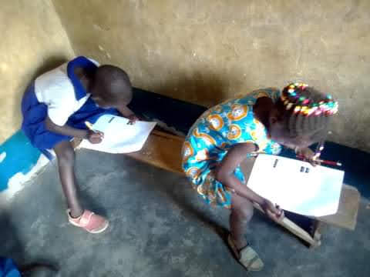
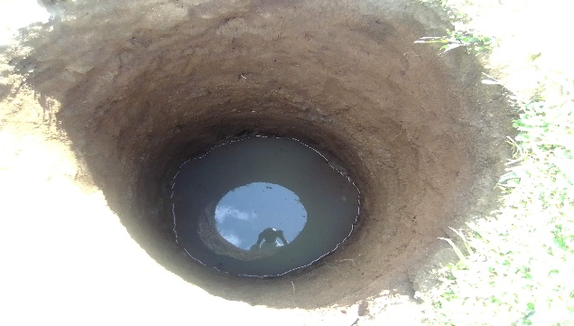
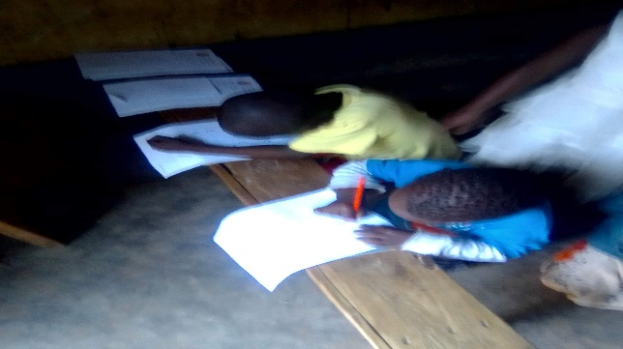
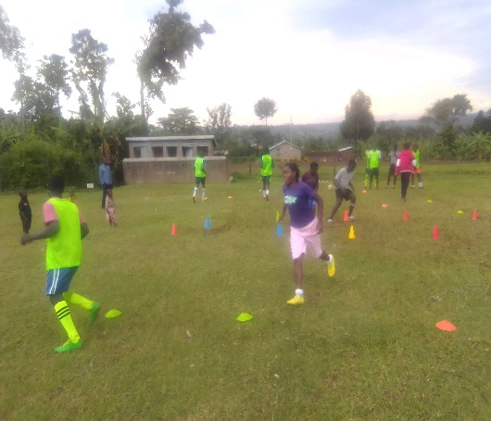
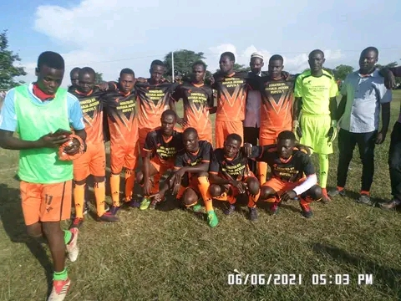
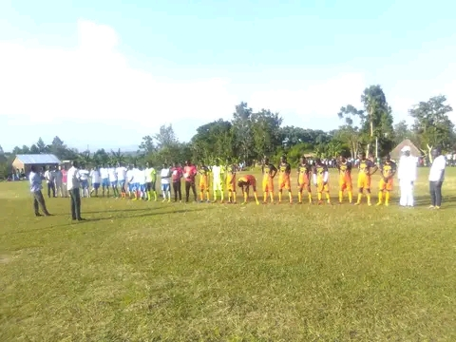
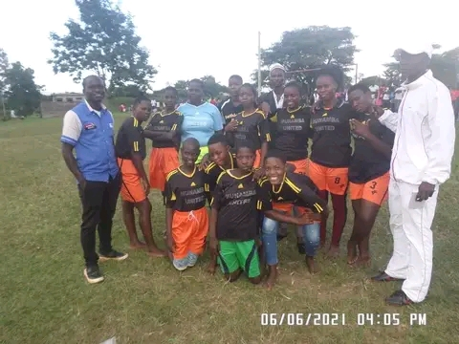
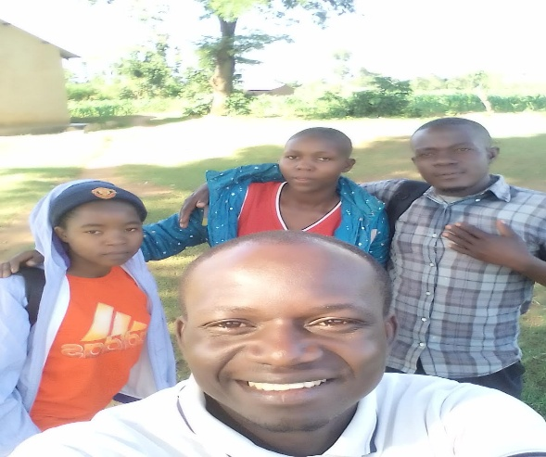
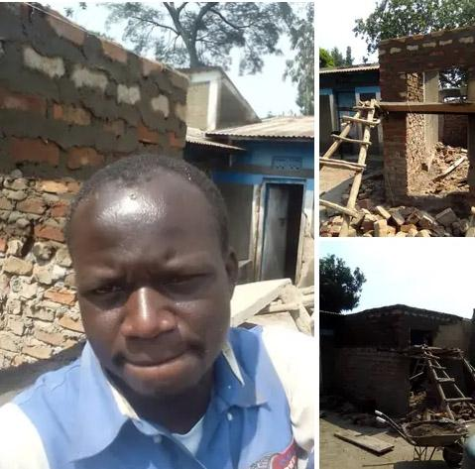
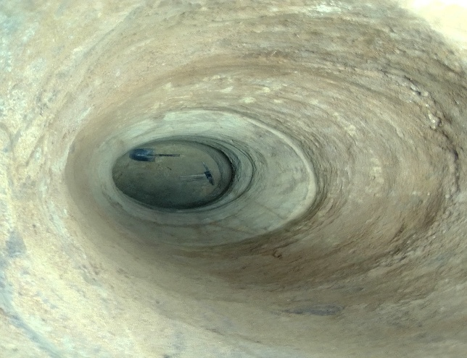
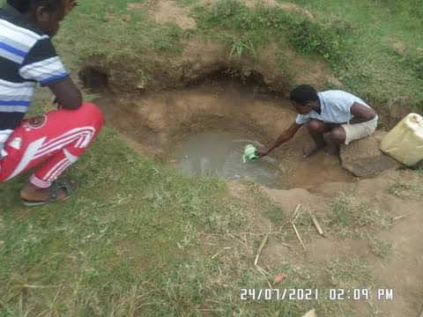
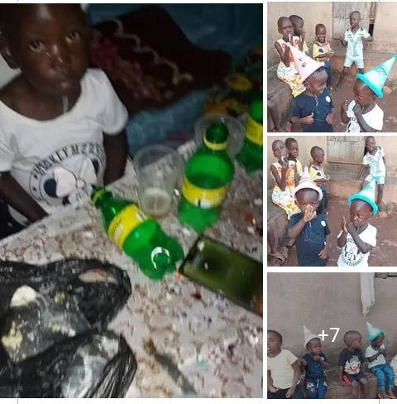
some of our organization pictures, please you can visit us on our social media platforms on the links below Ayetacharitablehandsafrica.org https://www.facebook.com/104247371755466/posts/pfbid02PgBu3cfuUmPJs5TbN7ZBMQc2WaepHGY1c4yErLtyMt78mfNpdjk5deyuq6gLZTQ2l/?app=fbl

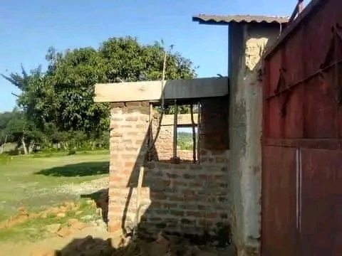
Ayeta glorious school foundation.
Location/About the Community
The Ayeta b charitable hands Africa organization Is located in Uganda, And our offices are located in located in Namisindwa district, our address is Ayeta charitable hands Africa P.O.BOX 1534 MBALE
“We looking for volunteers/partners/sponsors we can work with”
We have a glorious orphanage school foundation that were striving to construct and seeking for support. We so far have 174 orphans that schooling. They need, food, scholastic materials, toys for playing games, health nitrous food etc
Our water project needs proper covering and some holes needs drilling with maktors to reach on the water level under ground. We ask for volunteers/patners/sponsors to help oi.

Outcomes.
Acts of kindness have the potential to make the world a happier place, boost the feelings of confidence, relief, being in control, happiness, optimism, development and civilisation. can change the world for a New journey over our loved littles and fatherless, vulnerable and the needy feel the world a better place for them to stay . It may be another chance to teach them love and encourage them to do good deeds to others as as experience through themselves. it creates a sense of belonging and humor and give a sense of purpose in for them and all of us .

LEADERSHIP

Executive Team
- Mayanja Jackson Chief executive officer.
- Mupuya Robert Secretary.
- Miriam Aliba. Treasurer

Board of Directors
- Namanda Richard Executive director
- Netondo Ritah, Chairman
- William watoya vice Chairman

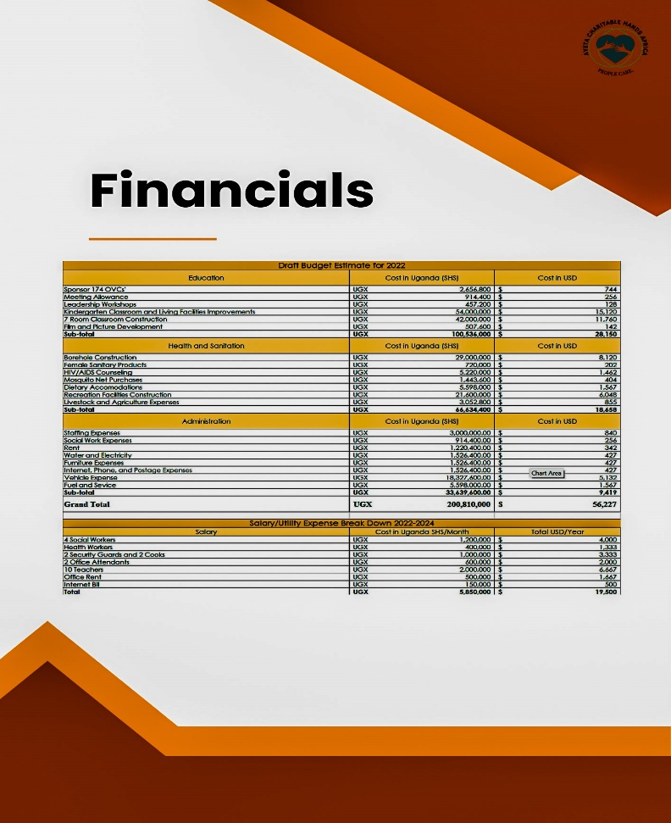
Project costs 2022/2024.
TO: Friends and we’ll wishers/partners/donor.
The management committee board of directors, (A.C.H.A) is pleased to submit this request for your viewing and assistance . We look forward to partnership in our cooperation effort to build a glorious school and orphanage to this community by putting up structures for further management of our organizational objectives, vision and mission In our project area, THE AYETA CHARITABLE HANDS AFRICA, we have a number of vulnerable children, Orphans, Semi Orphans and Street Children are found. The problem of orphan / street children is acute due to urbanization and industrialization. Due to the deaths of HIV/AIDS affected persons, Re-marriage of deserted / widowed / divorce women, absence of love and security in the families, Family disputes, Unwanted pregnancy of Trafficking / Sexually exploited girls; these orphans and street children are left without care and support. These children are involved in rag picking, pick pocketing, smuggling, participating in anti social behaviors and criminal activities

The project impact – an overview

In spite of planned development and special provision for accelerated socio-economic development of neglected/disadvantaged sections, the issue of orphan, semi orphan and street children is not properly addressed. In our project area many Orphan, Semi Orphan and Street Children are found. The problem of orphan, street children is acute due to urbanization and industrialization. Due to the Deaths of HIV/AIDS affected persons, Re-marriage of Deserted, Widowed, Divorce women, Absence of love and security in the families, Family disputes, unwanted pregnancy of Trafficking, Sexually exploited girls; these orphans and street children are left without care and support. These children are involved in rag picking; pick pocketing, smuggling and participating in anti-social, criminal activities. Therefore, we envisage mainstreaming these children in the national building by providing care, support and protection in our AYETA ORPHANAGE CHILDREN HOME.

The projects proposed in this scheme is meant for additional support to run the orphan children home, school, water and sanitation, Health facility and sports

The orphanage home aims to provide care, support and protection for 174 orphans, vulnerable & street children. This home has 4 care Takers, 10 Teachers, One Vocational instructor, two cook, one health attendant, two watchman. A doctor is conducting health check-up & providing medicines. All the inmates are being provided with 3 time’s nutritious food, one set of books and 4 sets of uniforms and regular dresses.

Through sports, we aiming so high in our soccer academy to support those interest and able ones to play the game, we encourage and instruct them with good moral standard both at the pitch and after. Our vision is to attain them with good soccer skills that will help them get soccer bursaries on different schools just in case some didn’t get sponsors, they can support themselves.

We have been identifying orphan / semi orphan / street children through our volunteers, citizens, police, women & child welfare department. We Pre-view of the incoming orphan / semi orphan / street child problems/difficulties. We counsel and arrange for Emotional acceptance of the orphan / semi orphan / street child. We provide Lodging and boarding facilities for all inmates at a rented building in Munamba town board, Bumaafu B. We arranged teaching facilities in nearby schools according to their age. We also provide home tuitions, scholastic materials, recreation and health care. But were aiming now to own our school very soon if more perhaps we attain some support for buying the land of school construction buildings and staff.

We have been running the Orphanage with local donations and contributions only. We mobilizing both cash and kind. We have limited resources to take care of about 172 orphans/ semi orphan / street children. But, day by day number of children are increasing due to various reasons.

We need additional support from the donors and philanthropists to meet the needs of increasing orphan / semi orphan / street children in our center. We seek support for about 3 years. Meanwhile, we will sustain to mobilize continuous local donations through exhibiting our good work and service.

We are planning to build permanent home by acquiring land from the donors and philanthropists. This home will have one Care Taker who besides handling day-to-day administration and will look after the hostel as warden. One Teacher, One vocational instructor, One cook, One attendant, One Watchman will be provided for the home. A doctor will be appointed as Center Medical Attendant on honorarium and all the inmates will be provided with health check-up, medicines, food, cosmetics, one set of books and two sets of uniform every year. The proposal covers 174 orphans.

Every child will be provided with nutritional diet, indoor and out-door recreation and play facilities and training in crafts and hobbies.

Impact analysis/statistics.

All the organisational projects are monitored at regular intervals through a “Project Advisory Committee (PAC)” constituted with the President/C E.O of the organization as convener/member secretary.

Authorities from the Funding Agency, Local

District Administration etc., will be nominated as members to the project advisory committee. This committee would meet periodically once in 3 months and advise on various aspects concerning implementation of project and review of the programs/activities undertaken.

The Project Advisory Committee will also review the accounts and audited statement.

Out comes.

This project has potential & impact full in main streaming of orphans & street children. Their basic needs are met & they will get new life through gaining knowledge, vocational skills, sports skills & life skills. They will get love & affection as if their parents provides. Their confidence level will increase & become good asset to the community. They are developed physically & psychologically & made as good & productive citizens. They will inspire by philanthropy & show humanity towards the poor communities.

^{Volunteer}

Currently since we began, our little team volunteer base team of volunteers have worked so much onto marketing the organisation through sharing our Facebook posts and videos and talking to different groups of people that would intervene in the giving helping hand of support onto our organisational goals, vision and mission.
We call upon to the world that please, we need more of your volunteering to our organization {A.C.H.A} . We have a volunteer structured program that you can look at on read to find out if it’s profitable for you to extend a hand of volunteerism to the Ayeta organization. You can reach us at any time our contact below.
Cell phone: +256756341107 , Email:(ayetacharitablehandsafrica@gmail.com)

